Lab Report-03
Problem Statement: Write the code of Merge Sort & Quick Sort algorithm.
Objectives:
• To arrange data in the correct order quickly and easily.
• To break a big problem into smaller parts to make sorting simpler.
• To make programs work faster when dealing with many numbers or data.
• To save time by using smarter sorting methods than basic sorting techniques.
Merge Sort
Code:
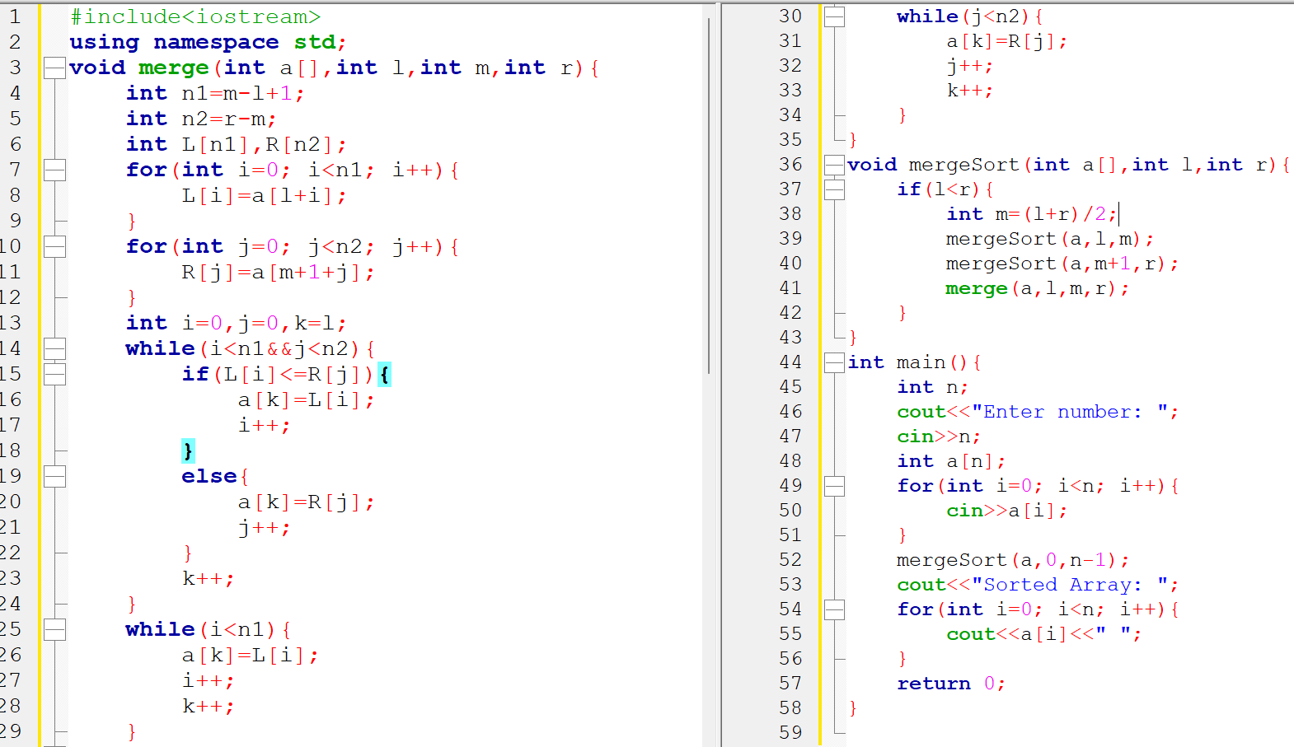
Input & Output:
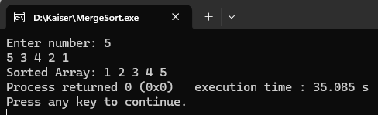
Quick Sort
Code:
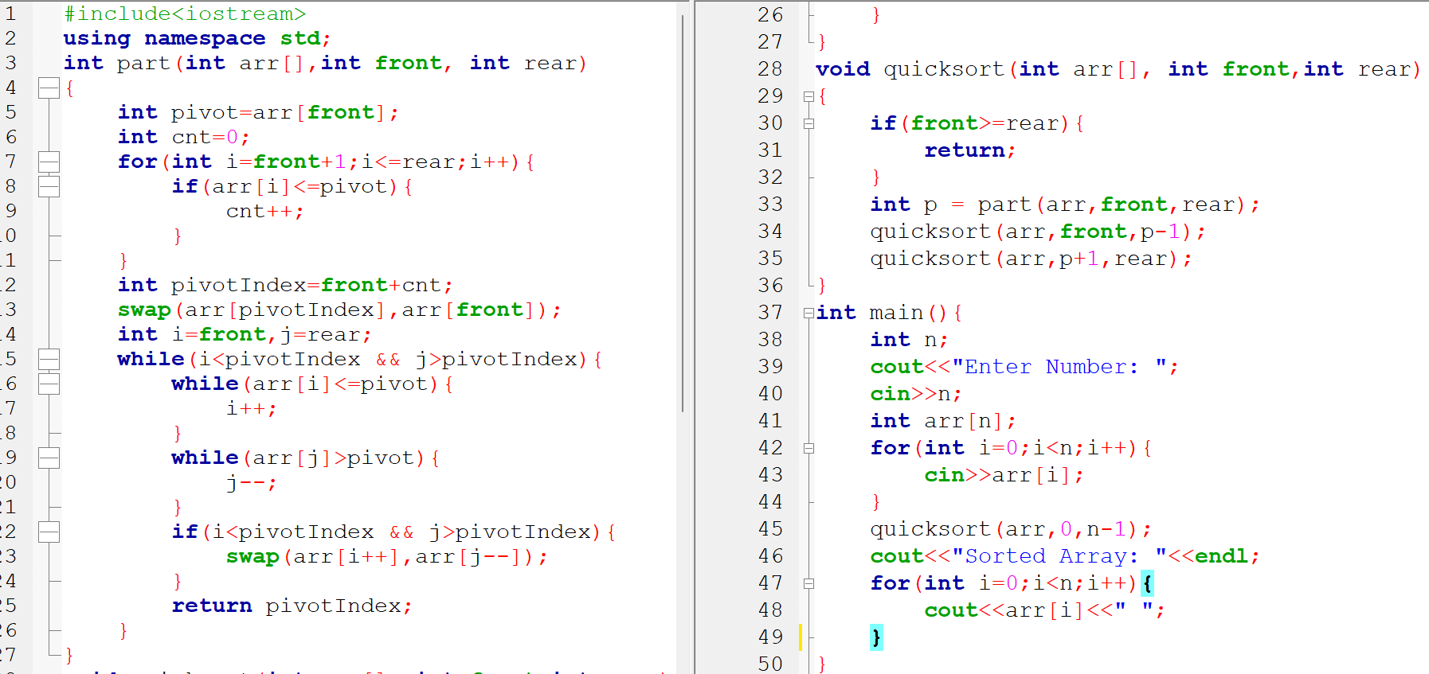
Input & Output:
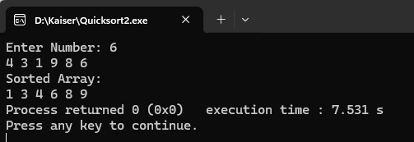
Conclusion:
In this lab, Merge Sort and Quick Sort are considered very useful sorting algorithms in programming. Data can be arranged in ascending or descending order more quickly and correctly by using these methods. The divide and conquer technique is also applied, where a large problem is divided into smaller parts to make the sorting process easier. Merge Sort is known for giving stable and accurate results, while Quick Sort is preferred because less memory is required and faster results are often produced. By writing and running these algorithms in C++, better knowledge about sorting techniques and program efficiency can be gained. These algorithms are widely used because better performance can be achieved when large amounts of data are handled.

